

Overview of Migrating from HPE OneView Ansible Module to HPE OneView Ansible Collection Format
Table of Contents
Executive Summary 3
OneView Ansible ADK Introduction 4
How Ansible Works 5
OneView Ansible Collection SDK Design and Architecture…………………………………………………………………………………………………………………………………5
The collection framework……………………………………………………………………………………………………………………………………………………………………………5
RedHat Certified Collections …………………………………………………………………………………………….……………………………………………………………………….6
What’s new in HPE OneView Ansible Collections……………………………………………………………………………………………………………………...…………..6
Summary 8
HPE Resources and additional links……………………………………………………………………………………………………………………………………………………………………………8

Executive summary
HPE and Red Hat® have partnered to deliver a better way for our customers to manage growing and more complex environment in their data center. This joint effort is an automation solution that frees administrators up so they can focus on efforts delivering more value to the business by accelerating delivery time for IT requests.
HPE OneView, combined with tools from our partners, help automate infrastructure lifecycle management, from deployment to updates. Using the HPE OneView API and integrations with our partners such as Ansible by Red Hat, system administrators can link HPE OneView into today’s popular automation toolsets.
Ansible by Red Hat helps orchestrate the application lifecycle, from deployment to configuration, to workflow optimization. So, while HPE OneView automates the infrastructure, Ansible automates the applications. Together, this provides a powerful and complete automation solution.
This document provides an overview of the benefits associated with migration from the HPE OneView Ansible Module to the HPE OneView Ansible Collection. This includes why the new collection format introduced by Ansible is architecturally superior to the previous format, and how the new collection format coupled with HPE OneView, through the HPE OneView REST API, provides a superior customer experience.

HPE OneView Ansible SDK introduction

HPE OneView makes it simple to deploy and manage today’s complex hybrid cloud infrastructure. HPE OneView can help you transform your data center to software defined, and it supports HPE’s broad portfolio of servers, storage, and networking solutions, ensuring the simple and automated management of your hybrid infrastructure. Software-defined intelligence enables a template-driven approach for deploying, provisioning, updating, and integrating compute, storage, and networking infrastructure.

The HPE OneView Ansible library Ansible provides modules to orchestrate and automate HPE OneView using Ansible playbooks combined with HPE OneView REST APIs. Each HPE OneView resource operation is exposed through an Ansible module. Specific modules are provided to gather facts about resources.

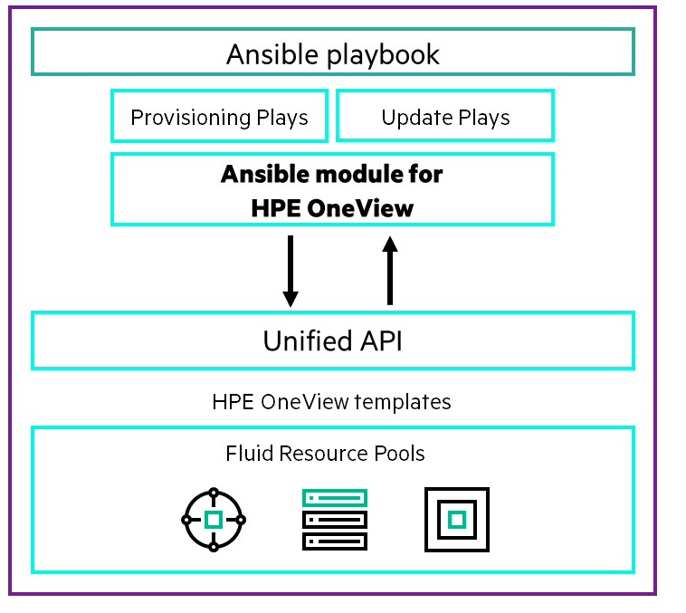
Figure 1 HPE OneView Ansible SDK.

How Ansible works

Ansible contains an automation engine that enables users to directly run and deploy playbooks. Ansible can work with multiple systems in your infrastructure at the same time. It does this by selecting portions of systems listed in Ansible’s inventory file, which defaults to being saved in the location /etc/ansible/hosts. Your inventory file can specify information such as IP address for each managed node in your data center. An inventory file can also organize managed nodes, creating and nesting groups for easier scaling.

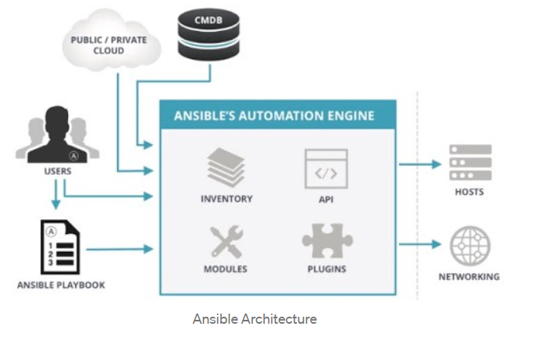

Figure 2. Ansible Architecture

HPE OneView Ansible Collection SDK design and architecture

The collection framework
The increase over the years in the success and popularity of Ansible, necessitated a change to the previous Ansible architecture. In late March 2020, the Ansible main development branch was separated from almost all of its modules and plug-ins. The previous architecture necessitated that Ansible version 2.9 need to support approximately 3,000 modules. Their maintenance, the integration of new features, packaging content, and blurred support responsibilities became untenable.
Ansible version 2.9, also known now as Ansible collections has been designed to accommodate the current growth and scale needed for success and provides a clear path for future development. Ansible collections represent the new standard of distributing, maintaining, and consuming self-contained Ansible content. By combining multiple types of Ansible content (playbooks, roles, modules, and plug-ins), flexibility and scalability have improved considerably. Managing content in this manner also becomes easier as modules, plug-ins, roles, and docs are packaged and tagged within a collection version.
Modules are the units of code Ansible executes. Each module has a particular use, from administering users on a specific type of database to managing VLAN interfaces on a specific type of network device. You can invoke a single module with a task or invoke several different modules in a playbook. Modules can be updated, renamed, and improved upon; roles can be updated to reflect changes in module interaction. Documents can be regenerated to reflect the edits, and all are packaged and tagged together. Starting in Ansible 2.9, modules are grouped in collections. Ansible content collections bring stability and predictability by breaking modules out from the core distribution.
Going forward, Ansible collections will be a major new part of every Ansible user’s experience and best practice recommended by Red Hat. The following are few of the advantages you can get when you migrate to the new Ansible collections.
- Ability to use project-relative collection and role paths, so you can have multiple independent Ansible projects that track their own dependencies according to the needs of the project.
- Enable content from the community.general Ansible collection to be adopted by a team of developers and moving it into a dedicated upstream location, with a dedicated Galaxy namespace.
- Maintainers of the newly migrated Ansible collection will be able to set up their own development and release processes as they want.

Red Hat-certified collections

With the launch of Red Hat Ansible Automation Platform 1.2, Automation Hub will be the source for Red Hat-certified collections. Certification provides users with the knowledge that the collection has been tested by Red Hat and is fully compatible with Ansible products. Additionally, collections creators can also package and distribute content on Ansible Galaxy. For automated organizations, this means that certified content is reliable and can be incorporated into production environment
What’s new in HPE OneView Ansible collection?
The HPE OneView Ansible Collection uses the new distribution format collection, introduced by the Ansible collections distribution format (that is, Ansible v.2.9). Now, Ansible content includes playbooks, roles, and plug-ins.
Ansible collections introduces:
- New installation approach. Multiple modules will not be installed by default (for example, paramiko, sshpass); you need to install them via pip or dnf on your own.
Note: In CentOS, it is available only via pip.

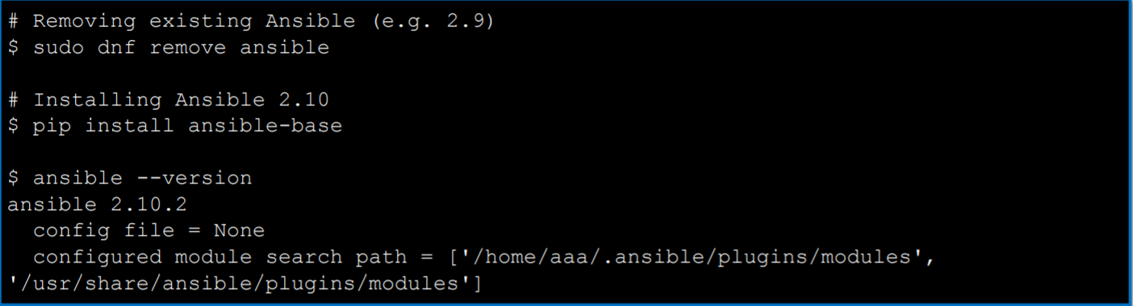
Figure 3. Example of Ansible Collection Installation

- New naming conventions modules to collections

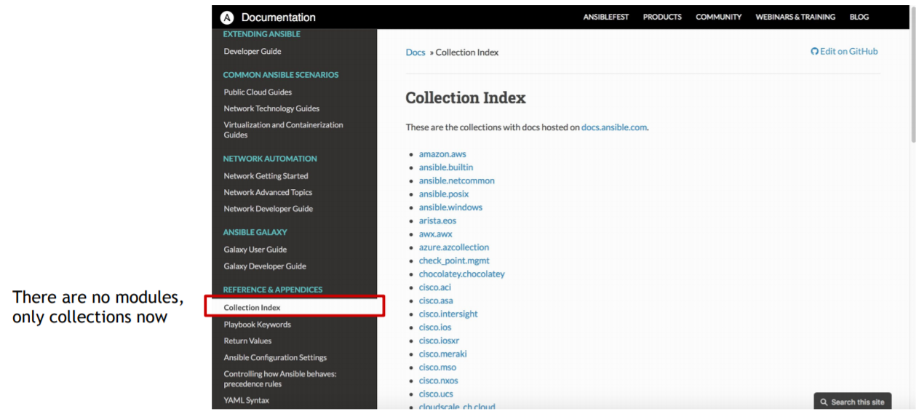
Figure 4. New Naming Conventions

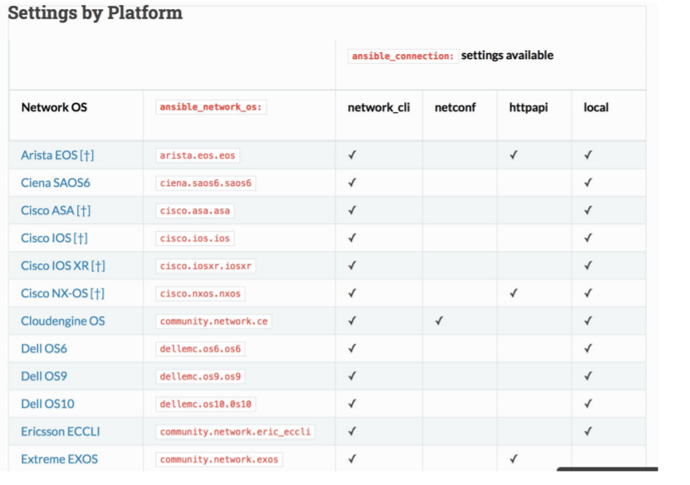

Figure 5. Network operating systems

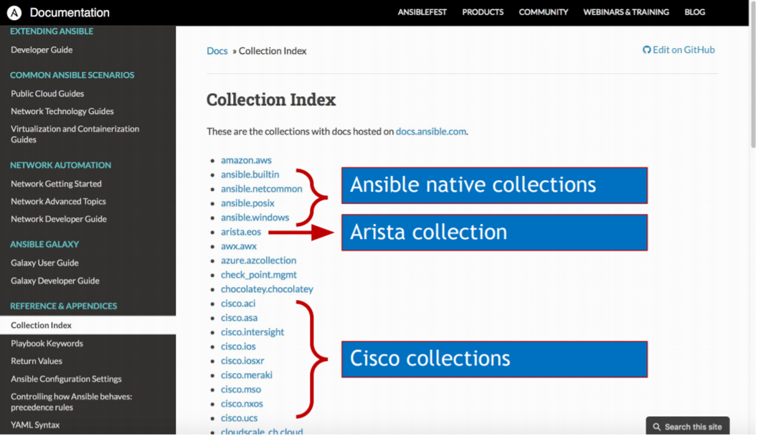
Figure 6. The Collection Index

- New collection structure
HPE OneView Ansible collection structure
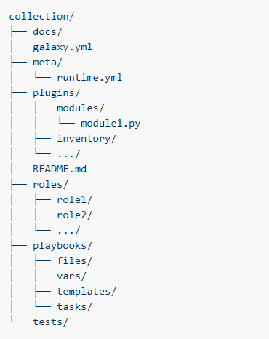
Figure 7. Collection Structure

For more details on how to move from HPE OneView Ansible Module to Ansible collection format, see the HPE OneView Ansible Collection Install and User Guide.

Where to find HPE OneView Ansible Collection
The new HPE OneView Ansible Collection can be found in multiple locations and can be consumed in several different ways. The collection is available at HPE, Red Hat, and Docker locations.
Table 1. HPE OneView Ansible Collection Locations

HPE OneView Collection | HPE GitHub | Ansible Galaxy | Ansible Automation Hub | Docker image
Ansible HPE OneView Collection module | Open-source  community project | Open Source Community portal  Ansible Galaxy provides prepackaged units of work known to Ansible as roles and collections. | Red Hat subscription  and support,  Ansible certified content backed by HPE and Red Hat. | Open-source:  The containerized version of the GitHub oneview-ansible-collection module is available in the Docker Store.

Summary
The HPE OneView Ansible Collection enables the transformation of on-premises infrastructure. This is achieved through the software-defined automated provisioning of bare-metal resources, including servers, storage, and networking. It can be done as part of an application deployment process or as a stand-alone resource alignment process. Using Ansible with HPE OneView allows customer to create a flexible and adaptive infrastructure. This flexibility is essential to addressing the need for organizational agility and supporting initiatives that best meet your customer needs.

This HPE developed collection has received Red Hat certification to ensure full alignment with Ansible’s new improved architecture and development. This certification process delivers content that is reliable and that can be incorporated into production environments. By coupling Ansible’s new collection format with HPE OneView, HPE shall continue to deliver a superior customer experience.

HPE resources

HPE OneView Ansible Collection Install and User Guide

HPE OneView Ansible Collection GitHub

HPE OneView Ansible Collection Ansible Galaxy

HPE OneView Ansible Collection Docker Image

RedHat Ansible Automation Platform

Learn more at

HPE OneView

